**Analysis Conclusions**

The final KNIME workflow is shown below:

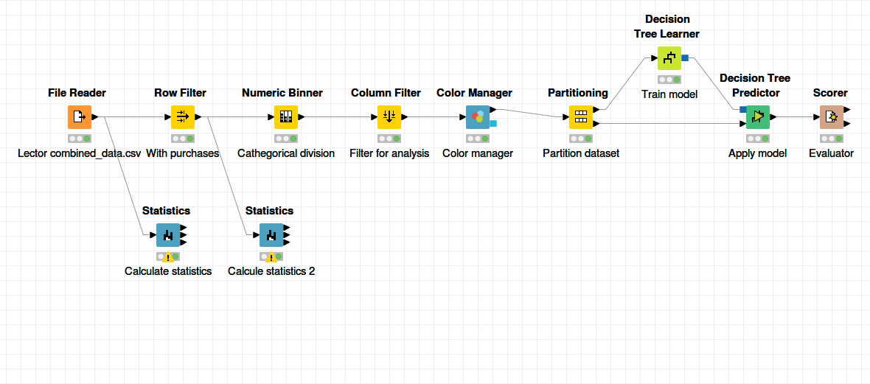

What makes a HighRoller vs. a PennyPincher?

Based in the decision results the principal attribute is the platform type. The iphone user trend to be high rollers and the users of the oder platmorms trend to be Penny Pinchers.

|  |
| --- |
| **Specific Recommendations to Increase Revenue** |
| 1. We need to focus our efforts to increase iphone users. We could make publicity of our game oriented in this platform. |
| 2. We want to the no iphone platforms users spent more money in our game. We could personalize some characteristics of our game, like an andoid flamingo to increase the interests of this platform users. |